|  |  |
| --- | --- |
| **Exp no:5** | **Half wave rectifier and full wave rectifier** |
| **Date:**  **10-11-2021** |

# Aim:

1. To set up a half wave rectifier and to find the dc value of rectified voltage
2. To set up a full wave rectifier and to find the dc value of rectified voltage

# Required tools:

LTspice software tool

# Theory:

**Half wave rectifier:**

The half-wave rectifier circuit converts AC to pulsating DC. The name half-wave represents that it converts only one-half of the sinusoidal input**.**

Vdc= Vm/π

Vrms= Vm/2

# Circuit Diagram:

# 

# Fig: Half-wave rectifier

# 

# Fig: Half-wave rectifier with capacitor filter

**Full wave rectifier:**

The Full-wave rectifier circuit converts AC to pulsating DC. The name full-wave represents that it converts both halves of the sinusoidal input**.**

Vdc= 2Vm/π

Vrms= Vm/ √2

# Circuit Diagram:

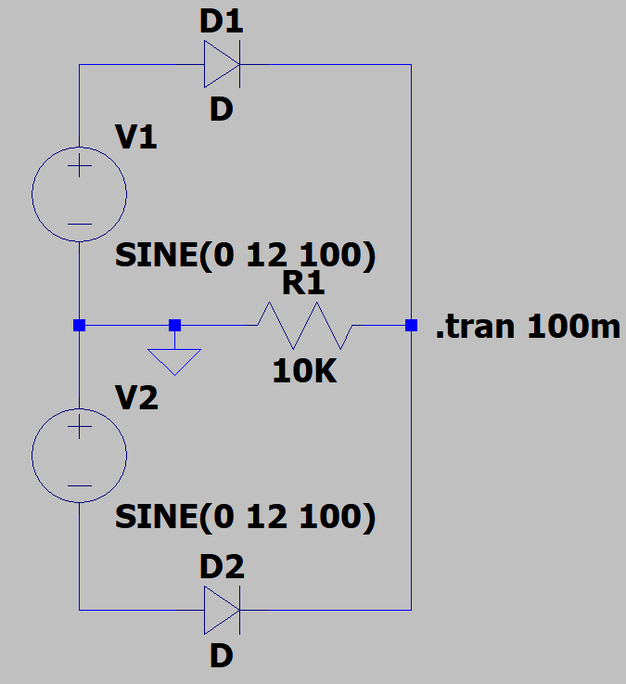

**Fig:** Full-wave rectifier

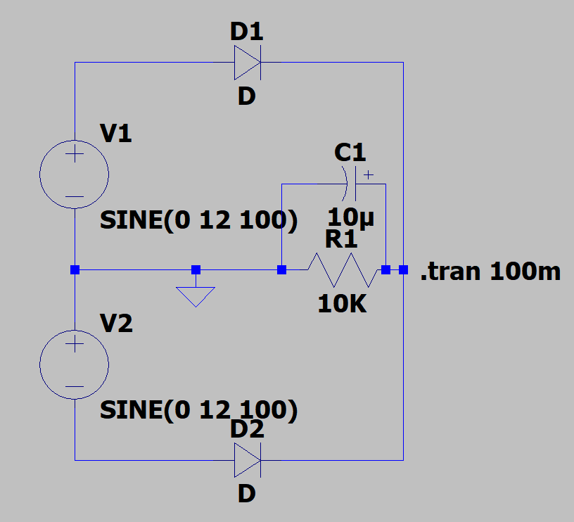

**Fig:** Full-wave rectifier with capacitor filter

**Procedure:**

1. Draw the circuit in LTspice schematic as shown in the circuit diagram for each rectifier circuit with and without rectifier.
2. Apply values to all the elements in the circuit.
3. Go to simulate tab, select tab edit simulation command, select transient analysis since we have to observe the waveform with respect to time.
4. Select the step time according to the frequency of input waveform.
5. Run the simulation.
6. Observe the input and output waveforms.
7. Calculate the Vm value by attaching the cursor to output waveform.
8. Calculate the Vdc, Vrms, ripple factor for Half wave and Full wave rectifier.

**Model graph:** 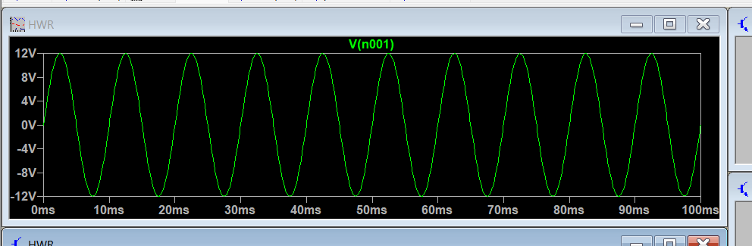

**Fig:** Input Waveform

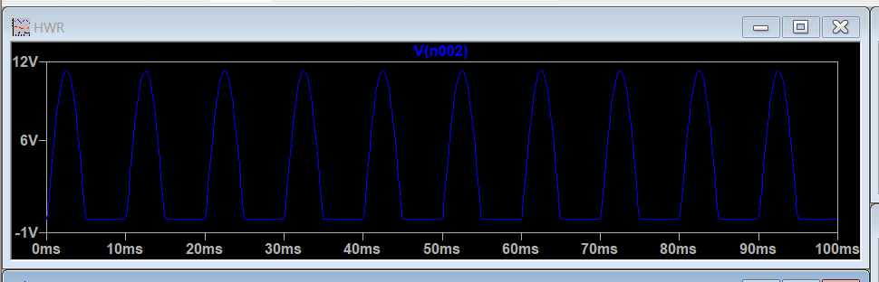

**Fig:** HWR ouput without filter

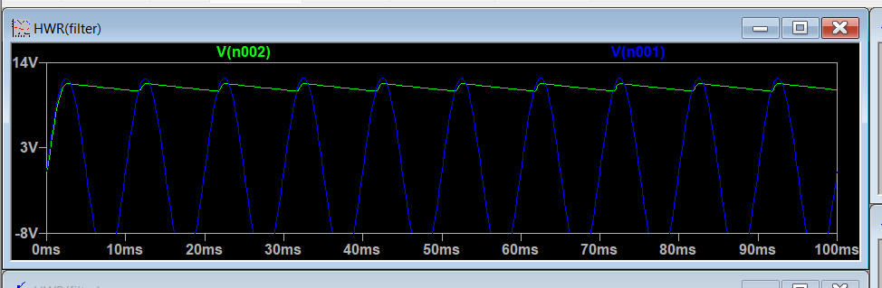

**Fig:** HWR ouput with filter

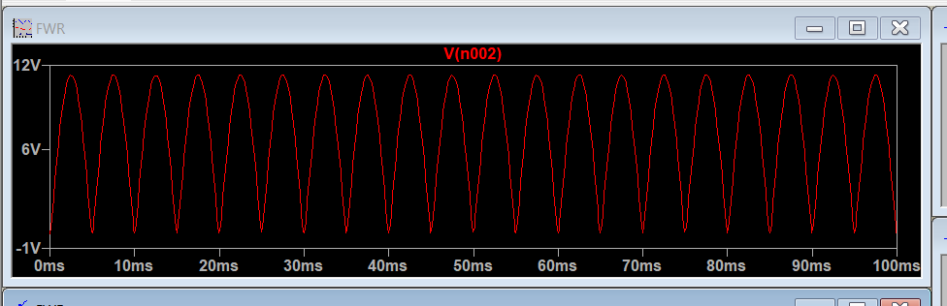

**Fig:** FWR ouput without filter

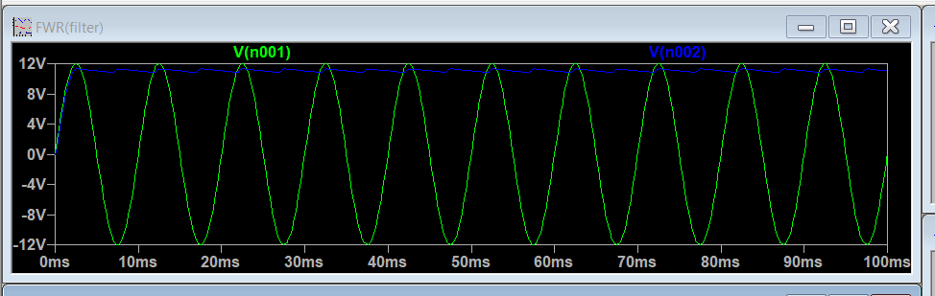

**Fig:** FWR ouput with filter

**Calculations:**

**For Half wave rectifier:**

Vm = 11.3V (From simulated output of HWR)

Vdc= Vm/π = 11.3/3.1415 = 3.596 V

Vrms= Vm/2 = 11.3/2 = 5.65 V

Ripple factor = $\sqrt{{\left(\frac{Vrms}{Vdc}\right)}^{2}-1}$ = $\sqrt{{\left(\frac{5.65}{3.596}\right)}^{2}-1}$ = $\sqrt{2.468-1}$ = $\sqrt{1.468}$ =**1.21**

**For Full wave rectifier:**

Vm=11.3V (From simulated output of FWR)

Vdc= 2Vm/π = 2 x 11.3/3.1415 = 7.192 V

Vrms= Vm/ √2 = 7.99V

Ripple factor = $\sqrt{{\left(\frac{Vrms}{Vdc}\right)}^{2}-1}$ = $\sqrt{{\left(\frac{7.99}{7.192}\right)}^{2}-1}$ = $\sqrt{1.23-1}$ = $\sqrt{0.23}$ = **0.48**

**Comparison of theoretical with simulated values:**

|  |  |  |
| --- | --- | --- |
|  | Theoretical value | Simulated value |
| Ripple factor for HWR | 1.21 | 1.21 |
| Ripple factor for FWR | 0.48 | 0.48 |

**Result:**

The half-wave and full-wave rectified outputs are simulated successfully.

**Inferences:**

1. The theoretical value of ripple factor for half-wave rectifier is same as simulated value
2. The theoretical value of ripple factor for full-wave rectifier is same as simulated value
3. The amplitude of the rectified output is reduced when the capacitor is connected to the resistor. Hence the ripple factor can be reduced with a filter.



Faculty signature:

Marks:

Student signature: